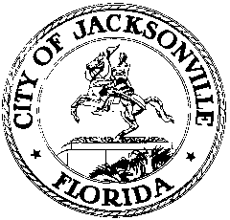

OFFICE OF THE CITY COUNCIL

117 WEST DUVAL STREET, SUITE 425
4TH FLOOR, CITY HALL
JACKSONVILLE, FLORIDA 32202
904-630-1377

CIVIL RIGHTS HISTORY INVENTORY MEETING MINUTES
Conference Room A, Suite 425, 4th floor, City Hall
June 12, 2018
11:30 a.m.

Location: Suite 425, Conference Room A, City Hall – St. James Building, 117 West Duval Street

In attendance: Rodney Hurst

Also: Yvonne P. Mitchell – Council Research Division

See sign-in sheet for additional attendees.

Meeting Convened: 11:40 a.m.

The Honorable Rodney Hurst convened the meeting and the attendees introduced themselves for the record. Mr. Hurst acknowledged the two emails received and incorporated appropriate details into the timeline. The committee completed the final revision of the timeline. Ms. Yvonne Mitchell will prepare the final draft for distribution to the Task Force on Wednesday, June 13th.

There being no further business, Mr. Hurst adjourned the meeting.

Meeting adjourned: 12:12 p.m.

Minutes: Yvonne P. Mitchell, Council Research
06.14.18 Posted 5:30 p.m.

Tapes: Civil Rights History Inventory Subcommittee Meeting – LSD
06.12.18

Handouts: Civil Rights History Inventory Subcommittee Meeting
06.12.18

